BACKEND ARCHITECTURES

Contents
BACKEND ARCHITECTURE FUNDAMENTALS 3
1. Architecture models 3
Monolith 3
Modular monolith 3
2. Microservices, service boundaries, and data ownership 4
High cohesion and loose coupling 4
Why companies accept microservice complexity 5
3. Synchronous vs asynchronous communication 5
Synchronous communication 5
Asynchronous / event-driven communication 6
Commands vs events 6
4. Reliability: networks fail 6
Idempotency 6
Retries, exponential backoff, and jitter 7
5. Financial backend discipline 8
State machines 8
Auditability and immutable history 8
Reconciliation 9
6. section vocabulary 9

BACKEND ARCHITECTURE FUNDAMENTALS
Goal: understand how backend systems are divided, how services communicate, who owns data, and how financial systems remain correct when networks and dependencies fail.
VERY IMPORTANT: Architecture is not about choosing the most complicated design. Use the simplest architecture that satisfies the real requirements.

1. Architecture models
A backend architecture mainly defines deployment boundaries, responsibility boundaries, communication paths, data ownership, and failure boundaries.
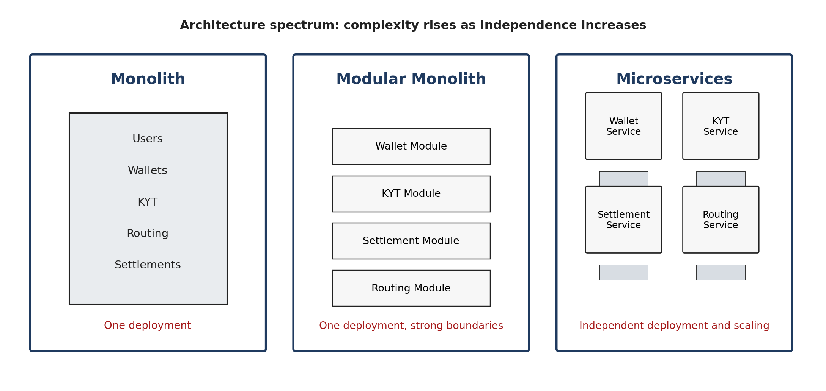
Figure 1. From monolith to microservices: independence increases together with operational complexity.

Monolith
- One application and usually one deployment unit.
- Simple local development, debugging, testing, and database transactions.
- Often a strong choice for a small team or early product.
- The real danger is not "one codebase"; it is uncontrolled coupling between unrelated responsibilities.

Modular monolith
A modular monolith is still one deployable application, but the internal modules have explicit boundaries. Each module owns its logic and exposes a controlled interface to other modules.
KEY IDEA: A modular monolith can be a deliberate professional architecture, not merely a temporary step before microservices.

2. Microservices, service boundaries, and data ownership
Microservices divide a system into independently deployable services centered on business capabilities. The point is not to make services tiny; the point is to create useful boundaries around domains such as Wallet, Settlement, Routing, KYT, Treasury, and Notification.
Good service boundary | Why it works
KYT Service | Owns risk scoring, rules, alerts, and risk data.
Settlement Service | Owns settlement lifecycle and settlement state.
Wallet Service | Owns wallet-related behavior and wallet data.
Routing Service | Owns provider selection and route execution policy.
Note: if using Kubernetes and docker, each service will be run inside a container (or multiple because usually we have replicas)

High cohesion and loose coupling
High cohesion means related responsibilities stay together. Loose coupling means one component depends as little as possible on another component's internal implementation.
- High cohesion: a KYT service scores addresses, evaluates risk rules, stores risk findings, and creates alerts.
- Low cohesion: a KYT service also sends marketing emails, manages invoices, and edits user profiles.
- Loose coupling: Settlement asks KYT for a risk result through an API or event contract.
- Tight coupling: Settlement directly reads and modifies KYT internal database tables.
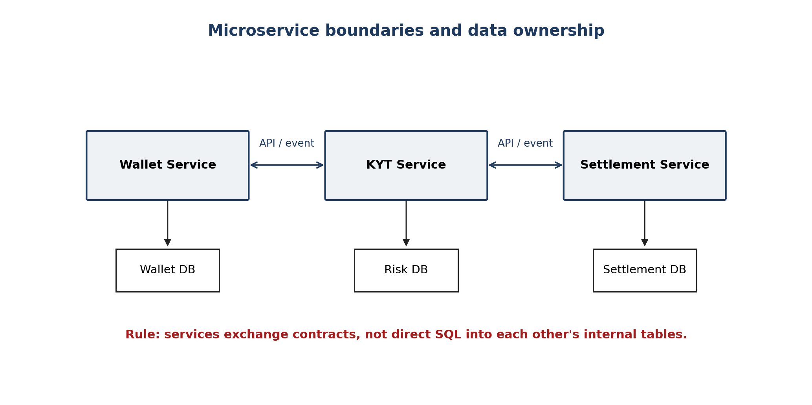
Figure 2. Each service logically owns its data. Other services communicate through contracts, not internal tables.
VERY IMPORTANT: "Database per service" means data ownership. It does not require a separate physical database server for every service on day one.

Why companies accept microservice complexity
- Independent deployment: one team can release without rebuilding the entire platform.
- Independent scaling: a high-volume KYT or blockchain-observer service can scale without scaling unrelated services.
- Failure isolation: an analytics failure should not automatically stop withdrawals.
- Clear ownership: teams can own business capabilities end to end.
The tradeoff is substantial: network failures, latency, distributed data consistency, observability, deployment orchestration, version compatibility, and retry behavior all become first-class engineering problems.

3. Synchronous vs asynchronous communication
Distributed backends normally use both request/response communication and event-driven communication. They solve different problems.
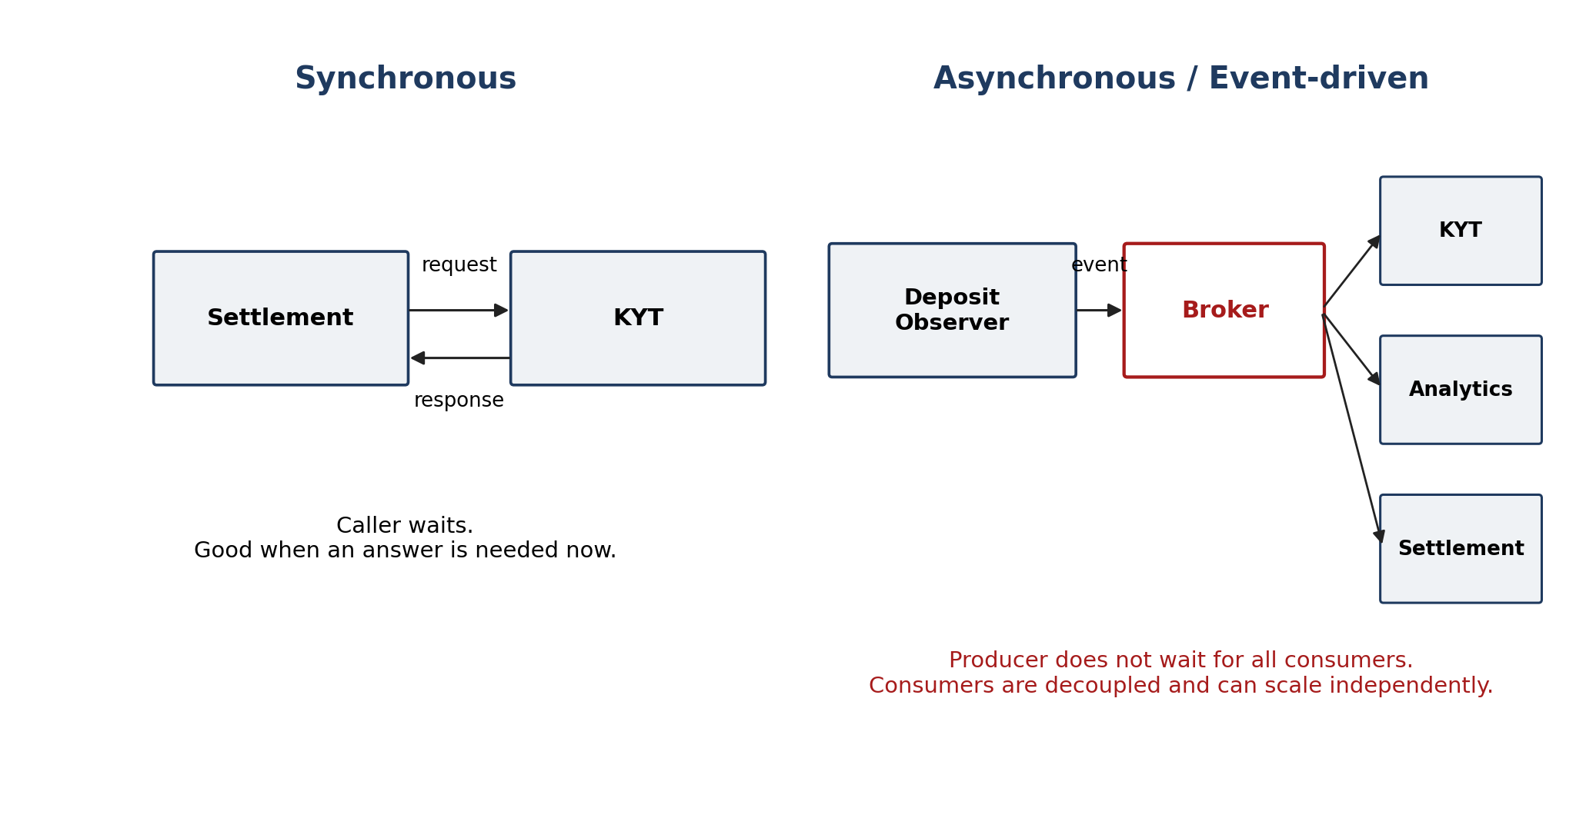
Figure 3. Synchronous calls wait for a result; event-driven communication decouples producers from consumers.

Synchronous communication
Use synchronous communication when the caller needs an answer now. Typical examples are getting a settlement status, generating a route quote, requesting a current balance, or asking a KYT service for a current risk result.
- Simple mental model: request -> processing -> response.
- The caller waits, so dependency latency becomes caller latency.
- If the downstream service is unavailable, failure can propagate up the call chain.
- Timeouts must be explicit; waiting forever is not an acceptable failure strategy.

Asynchronous / event-driven communication
Use asynchronous communication when publishing a fact that happened and one or more systems may react independently. Examples: DepositDetected, DepositConfirmed, WalletFlagged, SettlementCompleted, or TransactionFailed.
- Producer publishes an event to a broker or event channel.
- Producer does not need to know every consumer.
- New consumers can subscribe later without changing the producer.
- Consumers can process independently and at different speeds.
- This improves decoupling, but introduces delivery, ordering, duplicate-processing, and eventual-consistency concerns.
KEY DISTINCTION: Microservices describe how a system is divided. Event-driven architecture describes how parts can communicate. A system can use microservices with HTTP, events, or both.

Commands vs events
Command | Event
PerformSettlement | SettlementCompleted
ScoreWallet | WalletScored
SendNotification | NotificationSent
Commands ask for work to be performed. Events usually describe facts in the past tense.

4. Reliability: networks fail
In distributed systems, a request can succeed on the server while the response is lost. The client then sees an error but does not know whether the side effect happened. This is an ambiguous failure.
VERY IMPORTANT: If money is involved, blindly retrying an ambiguous request can execute the same financial operation twice.

Idempotency
An idempotent operation can be retried without repeating the side effect. For operations such as payments, the client sends a unique idempotency key that identifies one logical operation.
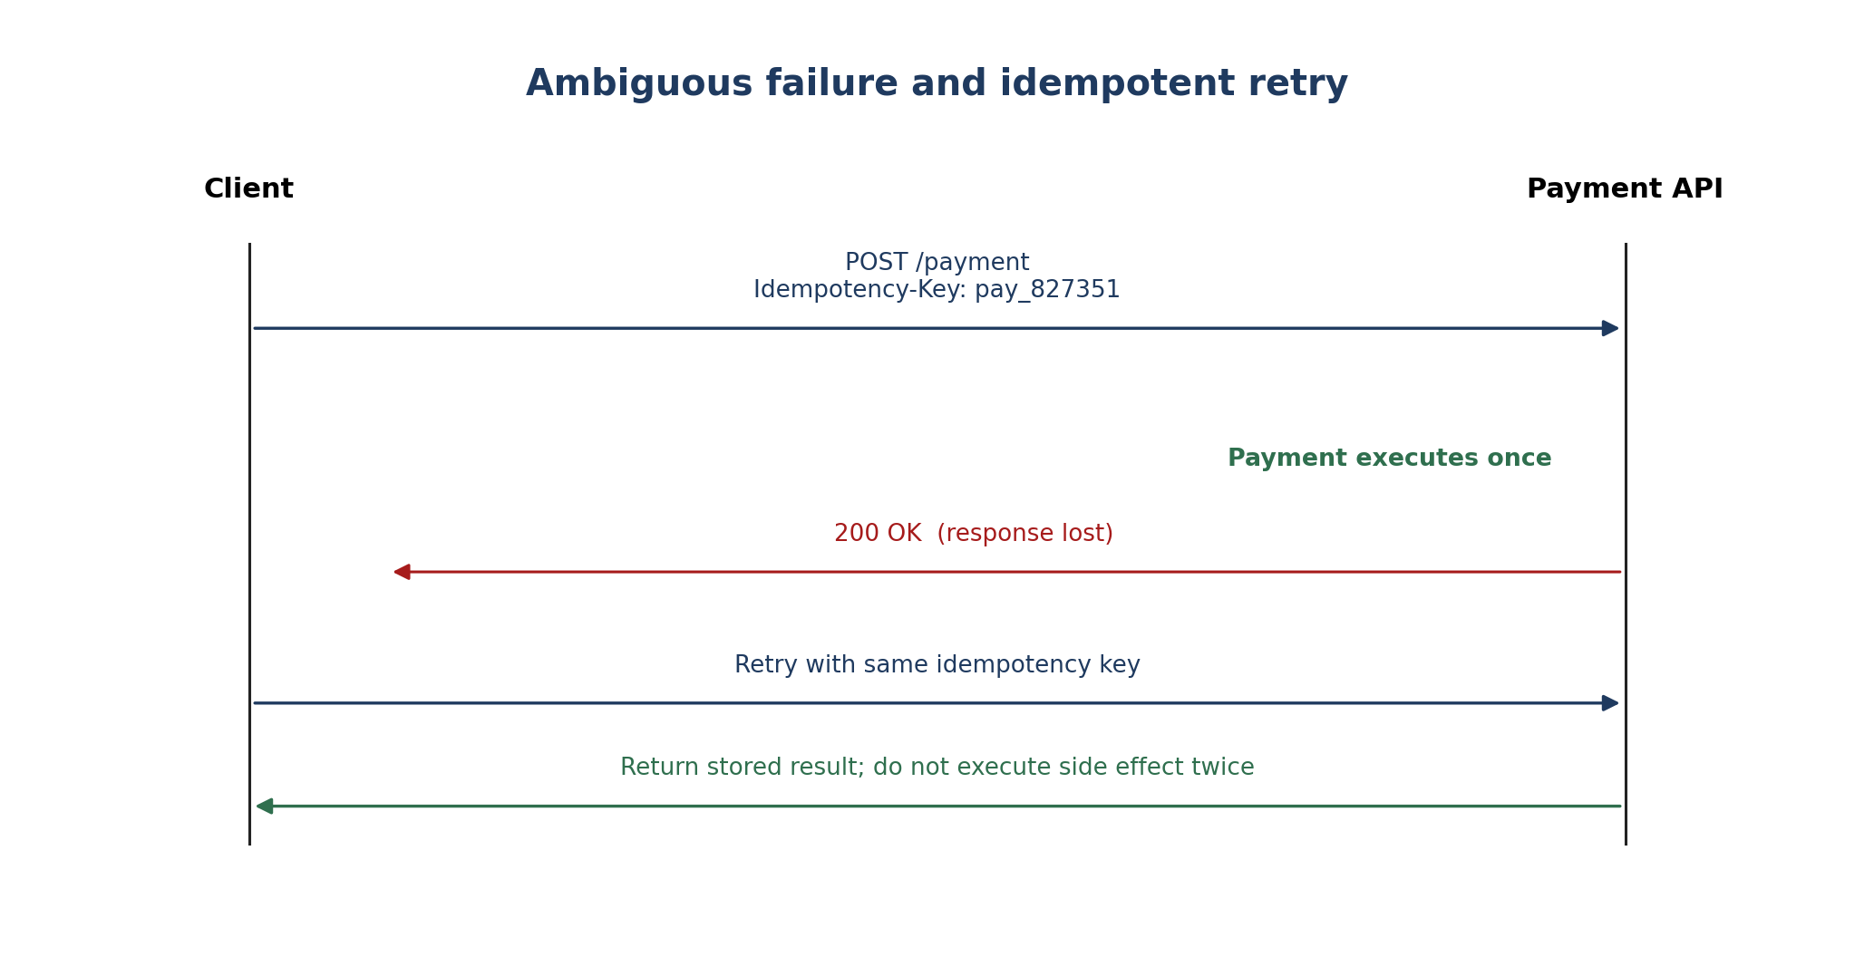
Figure 4. Same logical operation, same key: the server returns the stored result rather than charging twice.
POST /payments
Idempotency-Key: pay_827351
{
"amount": 10000,
"currency": "USD"
}

Retries, exponential backoff, and jitter
Retries are necessary, but retries must be safe and responsible. Exponential backoff increases the delay between attempts. Jitter adds randomness so thousands of clients do not retry at exactly the same time.
Mechanism | Purpose
Idempotency | Prevents duplicate side effects.
Retry | Attempts transient operations again.
Exponential backoff | Reduces pressure on a degraded dependency.
Jitter | Prevents synchronized retry waves (the thundering herd).
MEMORIZE: Robust remote calls often combine timeout + retry + idempotency + exponential backoff + jitter.

5. Financial backend discipline
Backend systems that control money need stronger guarantees than ordinary CRUD applications. The system should be able to prove what it expected, what actually happened, and how money moved through every step.

State machines
A state machine defines valid states and valid transitions. Instead of allowing arbitrary status changes, the system explicitly models the lifecycle of an operation.
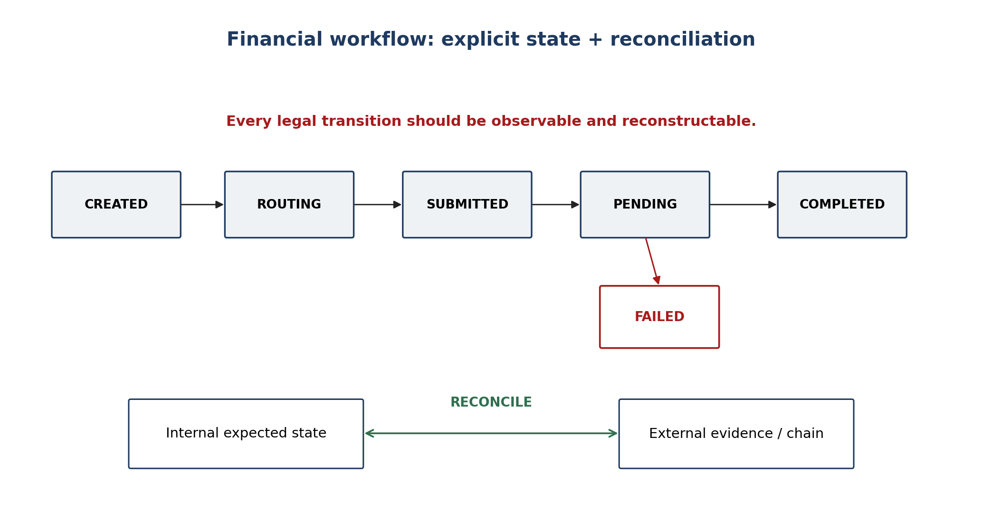
Figure 5. Explicit states make financial workflows observable and testable; reconciliation compares belief with external evidence.
- Example states: CREATED -> ROUTING -> SUBMITTED -> PENDING -> COMPLETED.
- A failure branch can lead to FAILED, RETRYABLE, or MANUAL_REVIEW depending on the design.
- Illegal transitions should be rejected; for example, COMPLETED should not casually return to CREATED.
- Every transition should be traceable with identifiers, timestamps, and relevant evidence.

Auditability and immutable history
Financial history should be reconstructable. Instead of keeping only the latest status, important systems preserve a history of meaningful events and state transitions. Stripe describes Ledger as an immutable, auditable log that can reconstruct past state and explain money movement.
VERY IMPORTANT: For financial infrastructure, "What is the current state?" is not enough. You also need "How did we get here?"

Reconciliation
Reconciliation compares internal expected state against independent external evidence. Examples include comparing an internal transaction record with blockchain state, or comparing a settlement marked completed with a provider or banking record.
- Internal DB says transfer completed; blockchain transaction reverted -> inconsistency.
- Internal settlement says completed; provider still reports pending -> inconsistency.
- Expected amount is 1,000; external evidence shows 997 -> investigate fees, routing, or accounting.
The objective is not to pretend failures never happen. The objective is to detect, bound, explain, and recover from failures.

6. section vocabulary
Term | Meaning
Monolith | One deployable application.
Modular monolith | One deployment with strongly separated internal modules.
Microservice | Independently deployable service centered on a business capability.
Bounded context | Boundary within which a domain's concepts and rules have a specific meaning.
High cohesion | Related responsibilities live together.
Loose coupling | Components depend minimally on one another's internals.
Synchronous call | Caller waits for the downstream result.
Event | A record that something happened.
Event broker | Infrastructure that receives and distributes events.
Data ownership | A service controls how its domain data is read and changed.
Idempotency | Retrying the same logical operation does not repeat the side effect.
Exponential backoff | Increasing delay between retries.
Jitter | Random variation added to retry timing.
State machine | Explicit states plus legal transitions.
Reconciliation | Comparison of internal belief with independent external evidence.
Auditability | Ability to reconstruct and explain what happened.

